Project Report Template

1. **INTRODUCTION**
   1. Overview

HealthHub Medical Clinic, a healthcare facility, relies on Zoho Books to manage patient billing and invoicing. They can track Medical service fees, manage insurance payment, and generate statement for patient. Zoho Books helps them maintain financial transparency and ensures efficient billing processes.

* 1. Purpose

**Personalised care:**

* As healthcare processes become more standardised, doctors will be better equipped to provide personalised patient
* care With personal health records, augmented by cost-effective screening that can be carried out in the home but
* with the results read remotely, health providers will be able to tailor their diagnosis and care based on the patient’s
* medical history, profile and other factors. Over time, the personalised prevention care .
* Providing one-stop access to their personal medical records, links to healthcare services and institutions and related information and tools so they can take control of their health.

1. **PROBLEM DEFINITION & DESIGN THINKING**

2.1 Empathy Map

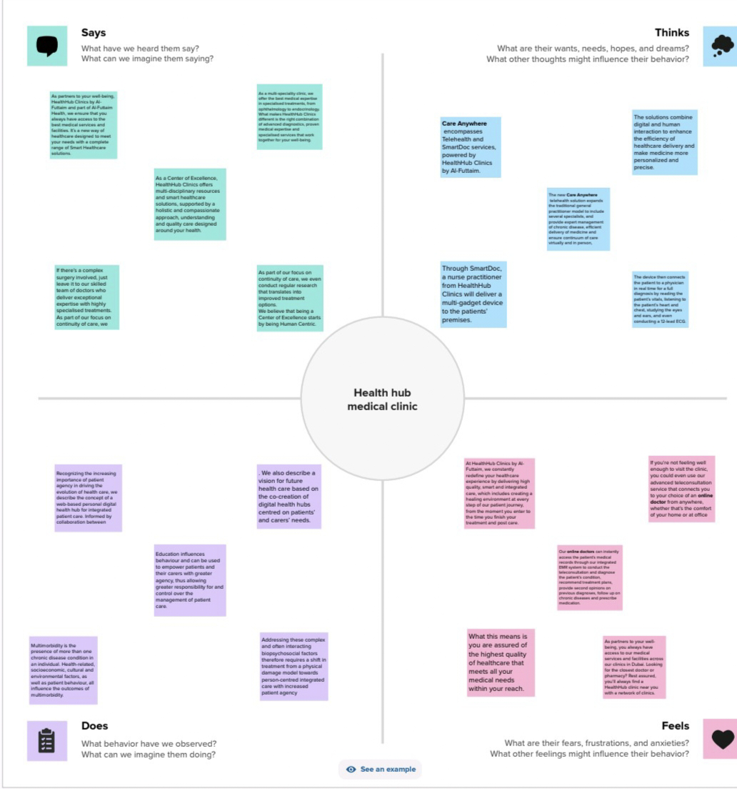



2.2 Ideation & Brain Storming Map

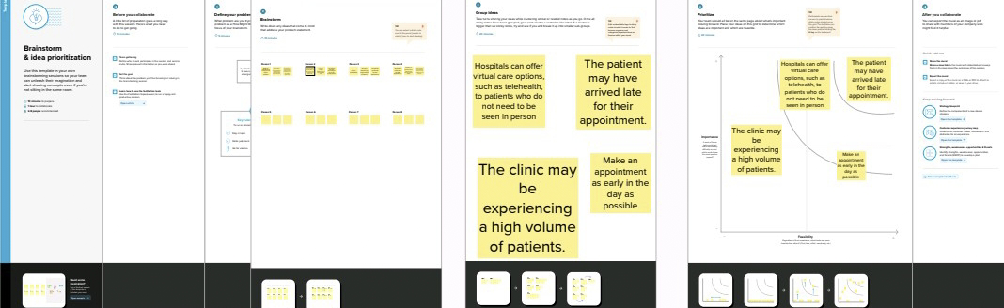

1. **RESULT**

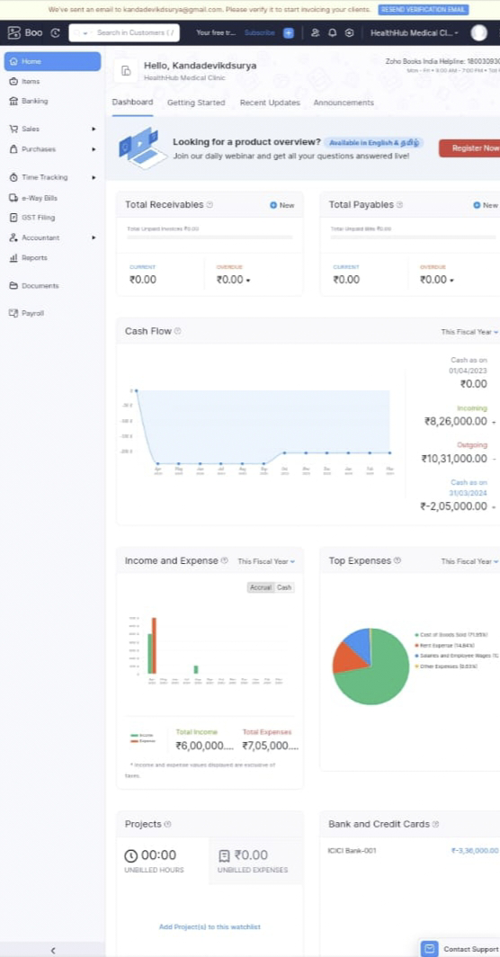

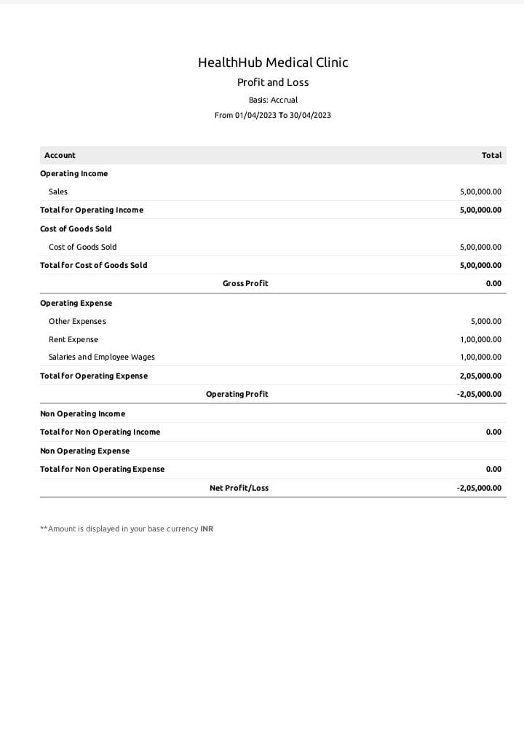

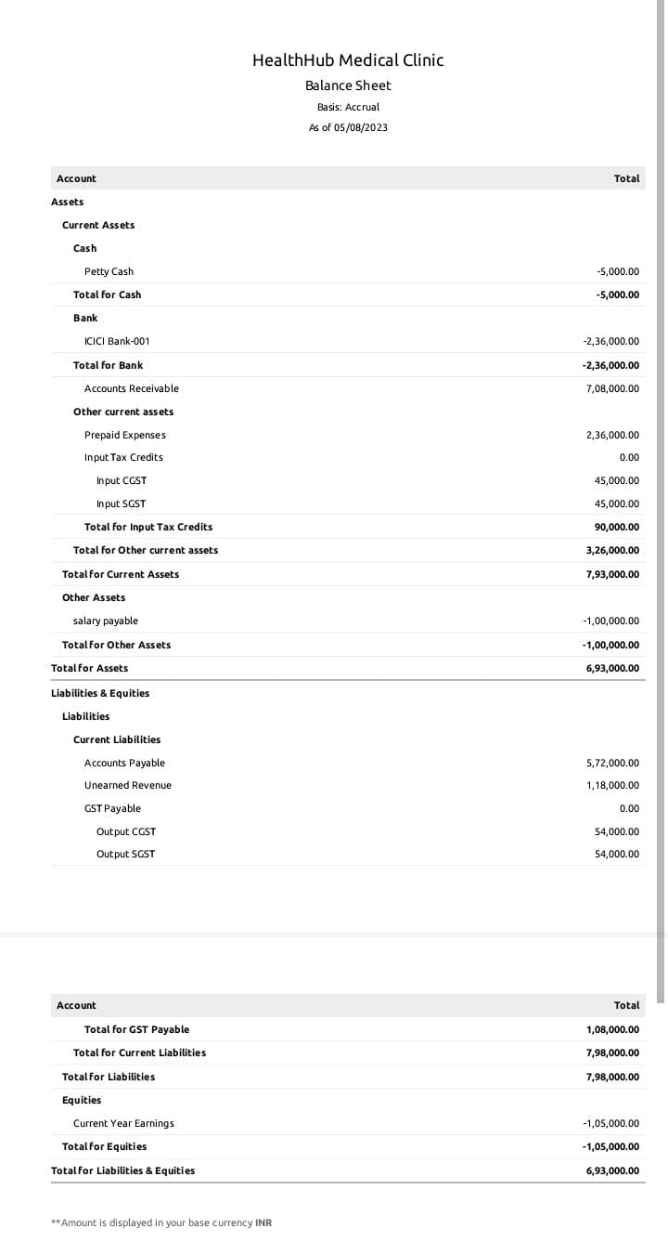

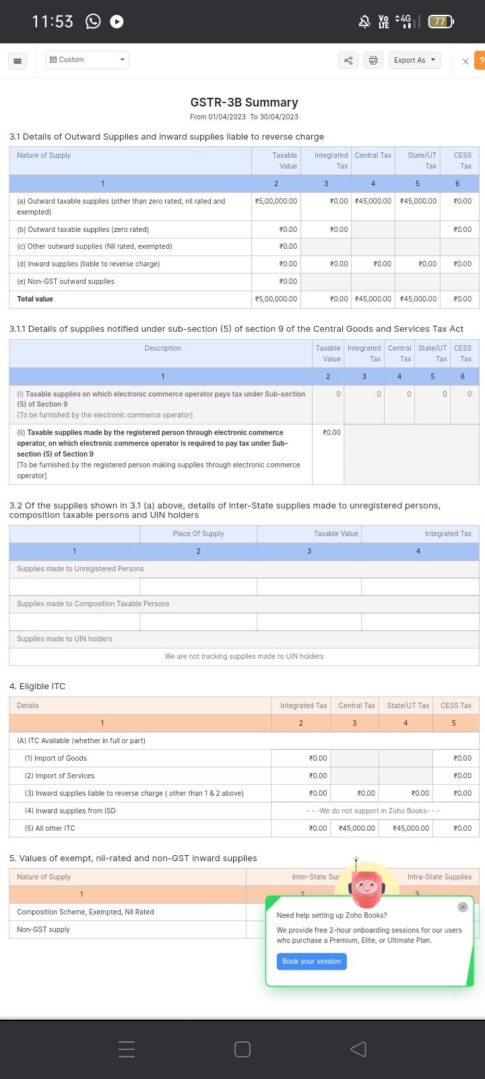

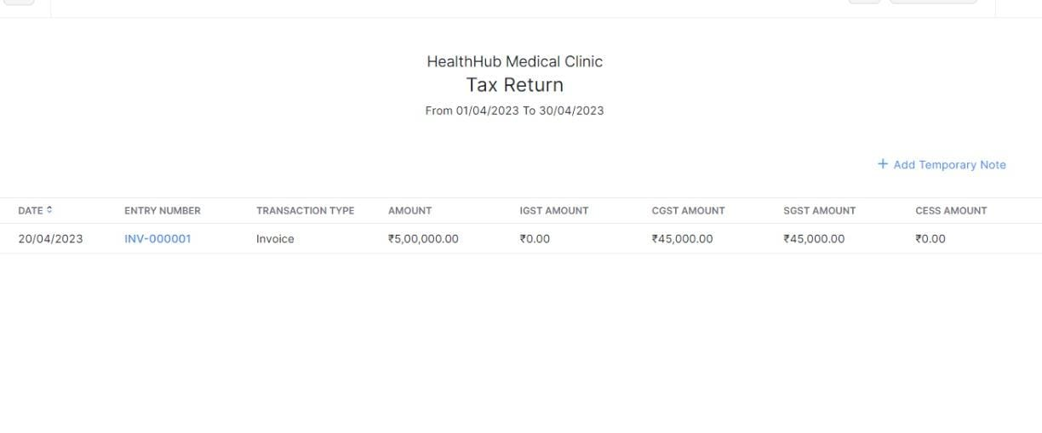

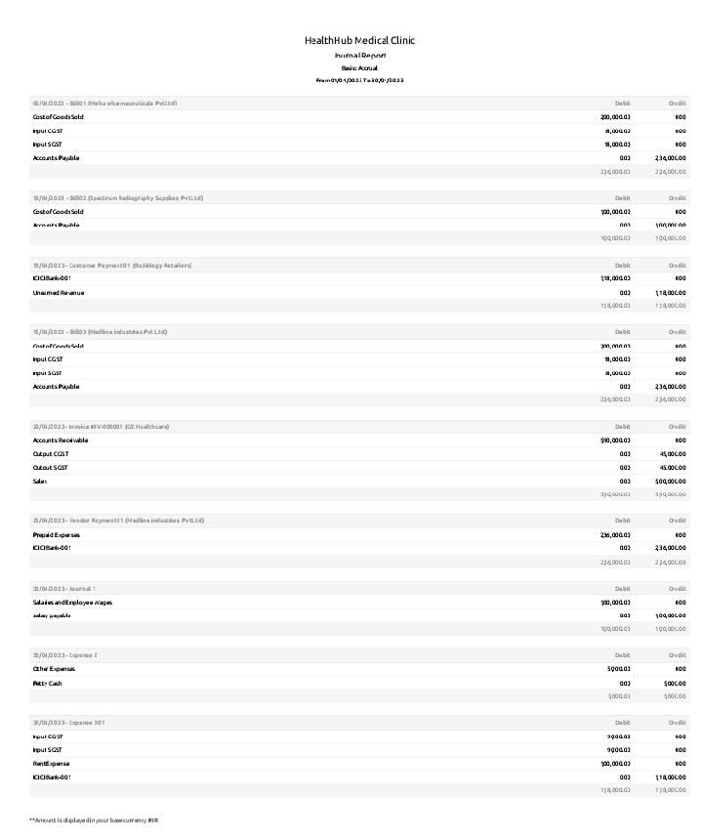

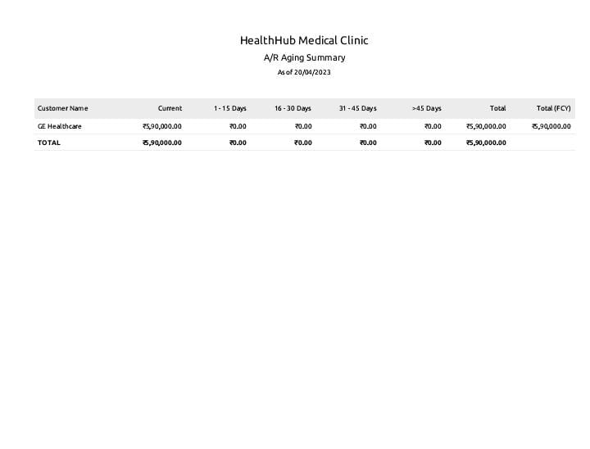

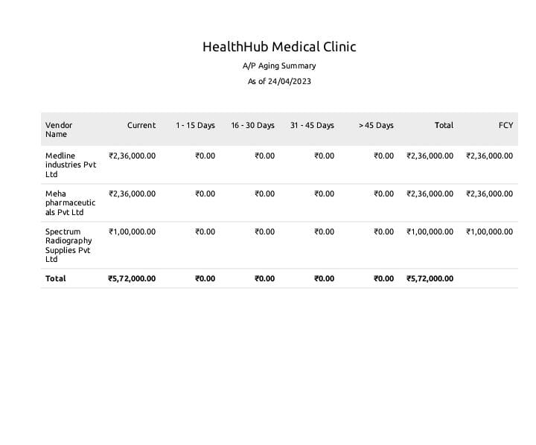



**4 ADVANTAGES & DISADVANTAGES**

* **Advantags:**
  + The goal of a health hub is to improve access to healthcare services and resources, reduce health disparities, and promote better health outcomes for individuals and communities.
* Disadvantage:
  + Healthcare workers have to work longer than average work time. Working more than 12 hours a day can be strenuous. Moreover, spending the whole day inside a room with the patients can be stressful.

**5 APPLICATIONS**

* medical service fees
* manage insurance payments
* generate statements for patients

**6 CONCLUSION**

Bright Ideas Consulting Ltd. creates innovative, evidence-based solutions, to enable organisations and the individuals who interact with them to thrive.We predominantly work with organisations who have a social mission including voluntary & community sector organisations.



**7 FUTURE SCOPE**

* Profit Sharing
* 401(k) Plan
* Defined Contribution Pension Plan